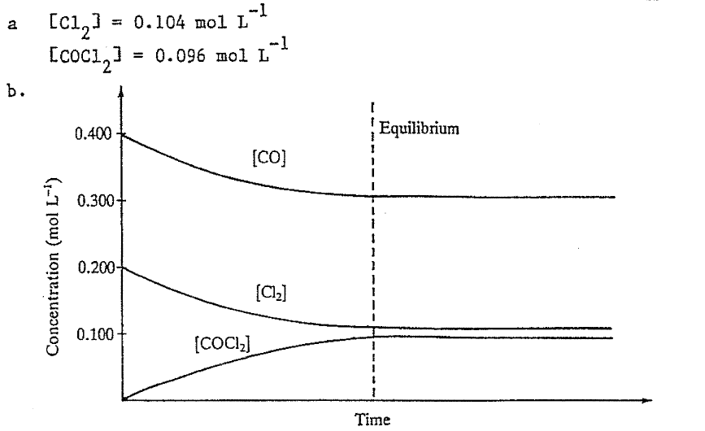

**CHEM 3AB EQUILIBRIUM Assignment (Foundations of Chemistry): SOLUTIONS**

1.

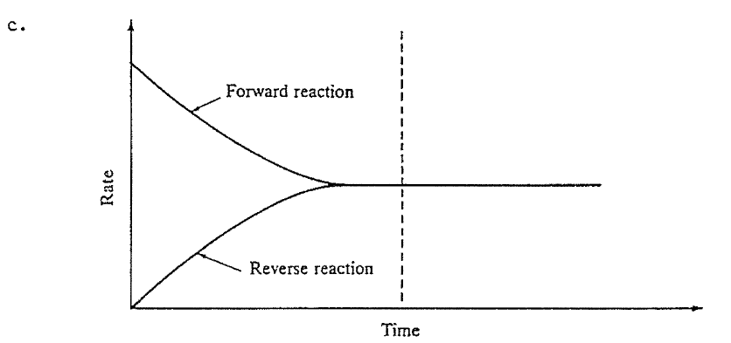



2.



3.



4. Temperature, Pressure and changes in Concentration through injection of reactants or removal of products.



Temperature ONLY!

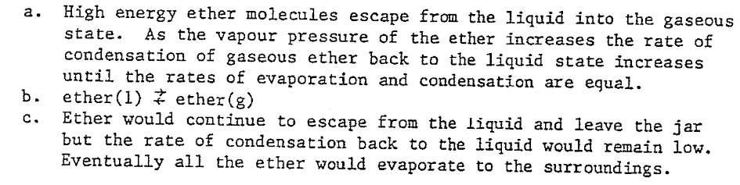5.

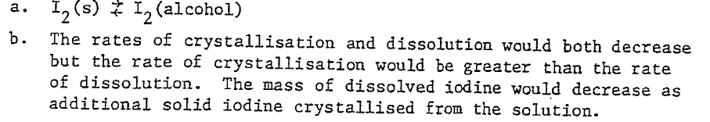6.

7.

When a bottle or can of “fizzy” drink is opened the air space above the drink in the sealed container has a saturation vapour pressure of CO2 gas. When the container is opened the “closed system” that previously existed is no longer present and carbon dioxide leaves the air space in the bottle or can. There is an immediate shift in equilibrium position to the LEFT in the equilibrium between aqueous and gaseous CO2. The dissolved carbon dioxide turns rapidly to gas and bubbles or effervescence is formed.



Warm fizzy drinks will go flat as the heat causes the evaporation of CO2 from the solution which shifts the equilibrium to the left to replace the escaping CO2. The quantity of dissolved aqueous CO2 will diminish and so the drink will become increasingly flat. The other factor to consider is that the system as written is EXOTHERMIC and so added heat will shift the equilibrium position towards the LEFT. The system will “***attempt to minimize the effect of the imposed change***” which in this case is added heat energy by shifting in a direction that will use some of it up. For both reasons the concentration of aqueous CO2 will decrease.

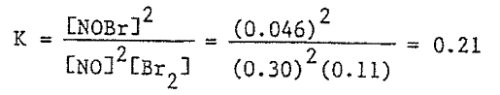

8.

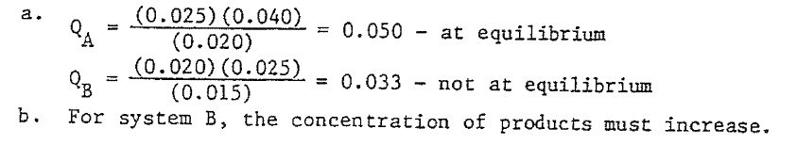9.

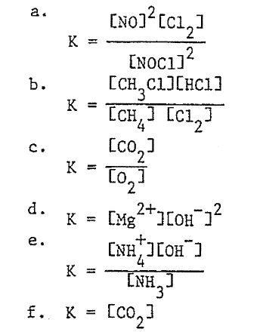10.

11.

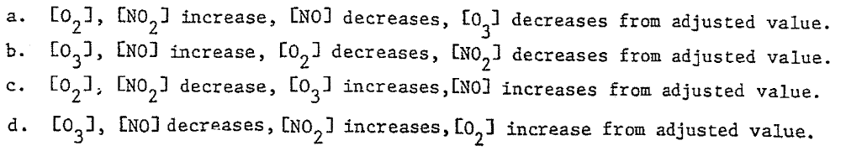

12.

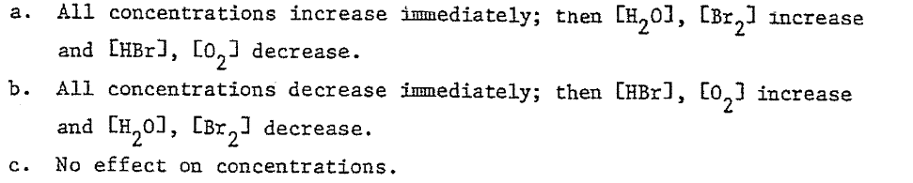13.

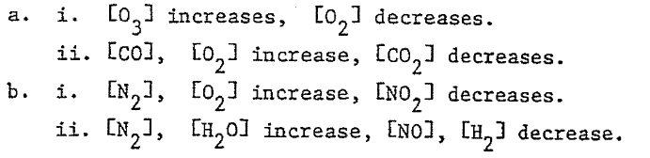

14.

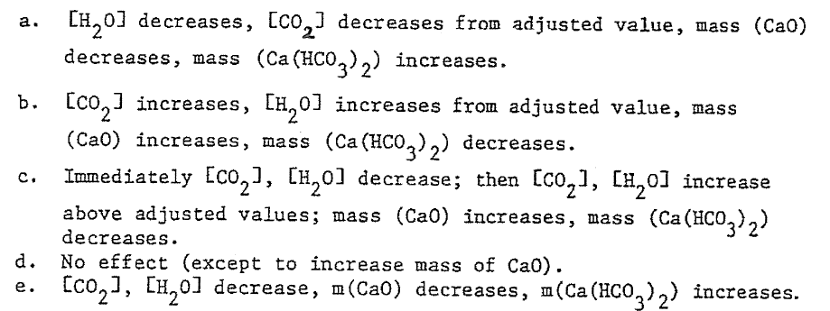

15.

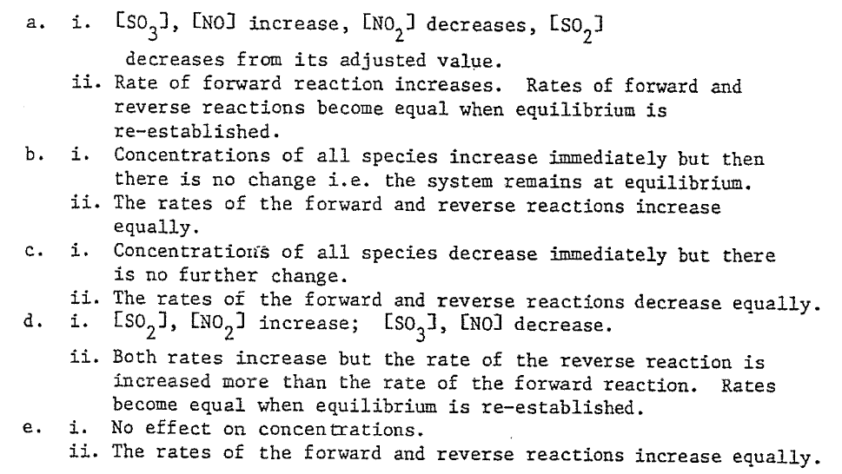16.

17.

Fast reaction rate will be achieved with **HIGH TEMPERATURE**, **HIGH PRESSURE** and the **PRESENCE OF A CATALYST.**



High equilibrium YIELD would be obtained with **HIGH PRESSURE** but **LOW TEMPERATURE**.



**YES** compromise conditions would be required for this reaction. While **HIGH PRESSURE** is of benefit for both rate of attainment of equilibrium and yield Temperature conditions are problematic. A **LOW TEMPERATURE** leads to a **HIGH YIELD** but at a **SLOW RATE OF ATTAINMENT** while **HIGH TEMPERATURE** will attain equilibrium **FASTER** but the **YIELD WILL BE LOWER**. A **COMPROMISE TEMPERATURE** that balances the demands of rate and yield will be required.

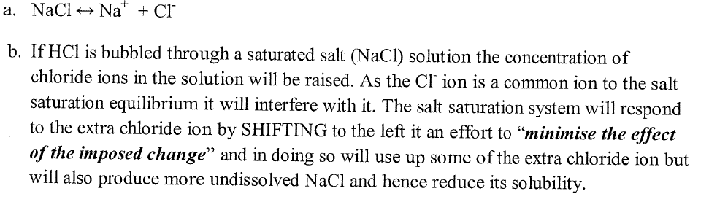18.

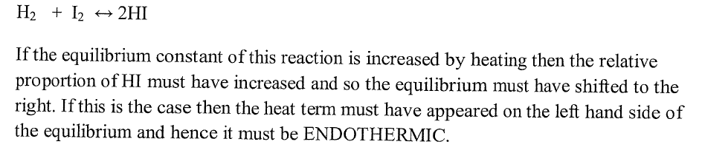19.

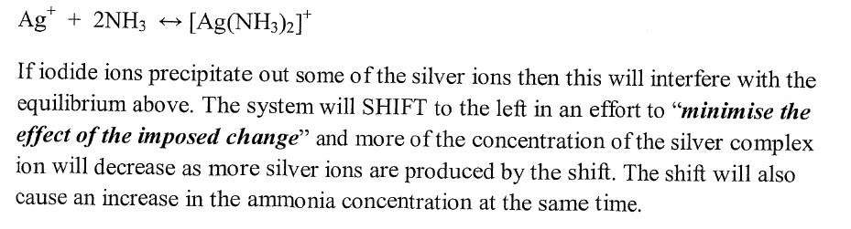20.

15.